

Air quality index improvements in London and Beijing: Effective mitigation of local emissions or anomalies in meteorology?

By

Cesare Pertusi

**School of Geosciences, The University of Edinburgh**

Abstract

Unusually low air pollutants concentrations were recorded during January 2018 in London and November/December 2017 in Beijing, respectively. Favourable meteorological conditions can temporarily enhance the dispersion of air pollutants, obscuring real concentrations for a certain period. Meteorological conditions during January 2018 and November/December 2017 were compared to four previous years to decipher whether the lower concentrations during these periods were due to local reductions of emissions or to conditions favourable for dispersion. Air-parcel back-trajectory clustering was used to compare relative frequency of air masses affecting the two cities. It was found that lower concentrations were due to both a reduction of local and regional mean concentrations and favourable meteorological conditions in both London and Beijing DETAILS ABOUT RESULTS. Air masses with lower levels of NO2 and PM2.5 in London and Beijing respectively had higher frequency in the period studied than in the compared years. Furthermore, air masses with high concentrations were less frequent in 2018 and 2017 than in previous years. Additionally, the recently implemented air quality policies in both cities had a positive effect in reducing air pollutants’ emissions. It was concluded that despite this success, Governments and authorities should consider regional transport of air pollutants when developing policies due to the considerable contribution of these sources to cities air pollutants’ levels. Future studies should aim to provide an understanding of the relative contribution of NO2 and PM2.5 regional transport in the cities of London and Beijing. This would provide useful clues to develop future effective air quality policies.

# 

# Acknowledgements

I would first like to thank the Authors of the scientific papers references in this research for their contribution to the advancement of atmospheric sciences and for giving me the inspiration for this article.

A special thank you to my friends Riccardo Fiorista, Anna Chirumbolo, Douglas Coenen and Samo Kollar and Matthew Logan for the time they dedicated to answering my questions about coding and supporting me in the learning process required to produce this thesis.

I would also like to thank Jean-Eudes Petit for the availability and support he has dedicated to me in using the Zefir package, which he developed.

A large thank you goes out to The National Oceanic and Atmospheric Administration’s Air Resource laboratory for the development of HYSPLIT model and their friendly team.

Finally, I would like to thank John Moncrieff, my academic supervisor, for overseeing my research and providing advice on the best methods to use to answer the scientific question in my thesis.

# 

# Introduction

Rapid economic development and urbanisation during the last two centuries has increased global air pollution, detrimentally impacting human health and the environment (Cui et al., 2020). Megacities, settlements with millions of inhabitants, contain many vehicles and much industrial activity, major sources of atmospheric pollutants (Chan and Yao, 2008; Cui et al., 2020) DOI: 10.1126/science.1176064. Air pollutants pose serious threats to human health and are associated with adverse environmental impacts (Tang et al., 2017; Walton et al., 2015). Air pollution levels are communicated publicly by governments using an air quality index (AQI), that differs between countries, according to the air quality standards set by the local government. These limits are stipulated by national and international institutions and vary according to the pollutant. They generally entail ambient concentration limits which should not be exceeded over a defined period, such as 24h-mean, annual averages, or hourly (Department for Environment, , n.d. (WHO, 2016)). For example, the World Health Organisation stipulated not to exceed a 24h-mean PM2.5 concentration of 25 μg/m3 or 10 μg/m³ annual means (WHO, 2016). Both the UK and the EU set NO2 hourly concentrations at 200 μg/m3 not to be exceeded more than 18 times a year(Department for Environment, n.d.; “Standards - Air Quality - Environment - European Commission,” n.d.). These pollutants were identified as posing the highest risks to human health such as to increases in mortality, decreases in life expectancy, decline in quality of life (Cui et al., 2020; Elkins, H. B., 1950; Tang et al., 2017; Walton, H., Dajnak, D., Beevers, S., Williams, M., Watkiss, P. and Hunt, A., 2015). Furthermore, PM2.5 and NO2 were associated with adverse environmental effects at local and global scale (MacCarty et al., 2008; Srivastava et al., 1975). In megacities, these pollutants have local sources or can be transported by surrounding regions (Li et al., 2016). NO2 is emitted primarily by pollutants that are generated by transport, energy generation, industrial and household heating and domestic and industrial combustion (Thomas and Devasthale, 2017). PM2.5 is mainly generated through wood and coal burning, industrial combustion, and road transport (Zíková et al., 2016).

London and Beijing have a legacy of extreme levels of air pollution. London has consistently exceeded NO2 annual limits since the early 2000nds. The London Air Quality Network was formed in 1993, in an attempt to monitor and reduce London’s extreme pollution levels(“Brief history - Defra, UK,” n.d.). It comprises numerous sites across London and together with the Automatic Urban and Rural Network (AURN), they form the main authority used for compliance reporting against the Ambient Air quality directives, the European directive which sets legally binding limits for concentration of main air pollutants(“Brief history - Defra, UK,” n.d.). These authorities contributed to public information and the development of different air strategies to contain urban emissions such Ultra low emission zone in April 2019, the low Emission Bus zones and the T-charge for dirtier cars in central London(Greater London Authority, 2019; Matters, n.d.). Beijing, due to a quadruplication of urban extent between 200 and 2009, and the country’s heavy reliance on coal burning for energy generation, has always been dealing with severe environmental issues concerning PM 2.5 pollution (Chen et al., 2015; Tang et al., 2017). In January 2013, Beijing’s PM 2.5 levels reached a value 75 times the WHO limits(Cheng et al., 2019). Since then, The Beijing Environmental Protection Bureau, divulgates air quality readings from 27 monitoring stations(“Ambient air quality standard,” n.d.). Numerous stringent measures for reducing PM 2.5 emissions in China, including the transition to cleaner energy sources, switching energy production from coal to natural sources (Cheng et al., 2019). Pollution levels have been increasingly ameliorated between 2013 and 2017, with a 54.7% reduction in pollution between those two periods (Cheng et al., 2019). In January 2018, The Chinese government claimed Beijing’ Air pollution had seen a sharp improvement, with PM2.5 concentrations in November and December 2017 being the lowest observed in 5 years(“Reality Check: Is Beijing’s air quality better this winter? - BBC News,” n.d.). Similarly, in January 15th 2018 the London City hall reported the city had the cleanest air in 10 years(“London’s January air quality ‘best in 10 years’ - BBC News,” n.d.). London’s NO2 concentration had not broken legal limits in mid-January, when usually was exceeding NO2 limits by 6th of January every year(“Lethal and illegal,” 2016). However, at the end of January 2018, the BBC reported Brixton road (A LAQN station) had broken the yearly limits(“London hits annual air quality limit in one month - BBC News,” n.d.). As Spatio-temporal air pollution concentration in urban areas depends not only on emission sources and concentration, but Is also influenced by meteorological conditions, the lower pollution levels might have been caused by weather creating favourable conditions for the rapid dispersion of air pollutants(Grundström et al., 2015; Shi and Harrison, 1997). Previous studies revealed that meteorological conditions are main factors influencing day to day air pollutant’s measurement( He et al., 2017; Pope et al., 2014). STUDIESS Especially in winter, when wind speeds are highest and temperature are lowest, there are favourable conditions for the diffusion, transfer, and transport of both NO2 and PM2.5(He et al., 2017; Pope et al., 2014). Moving air masses can rapidly capture and transport pollutants away from their sources, causing a temporary reduction in pollutants concentrations(Li et al., 2017), this is particularly true for Beijing. As it is tricky to track the movements of air masses and associated pollution in real time, models have been developed to simulate atmospheric conditions and decipher the sources and pathways of atmospheric pollutants (Warner, 2018). The Hybris Single-Particle Langrian Integrated Trajectory model (HYSPLIT) is a computational system for simulating air parcel pathwaysfor the investigation of transport pathways of air (Warner, 2018). This model, developed by the National Oceanic and Atmospheric Administration (NOAA) Air Resource Laboratory (ARL) computes theoretical paths of air parcels (trajectories) that can be grouped together (mean clusters) according to similarities in space and time (Stein et al., 2015; Warner, 2018).

This paper aims to compare the main patterns of air masses in the years 2018 and 2017 in London and Beijing respectively with previous years to understand whether the claims of the respective governments about the amelioration of air pollution in those years were due to a local reduction in PM 2.5 and NO2 concentrations or to temporary favourable meteorological conditions for their dispersion.

# Methods

Figure : Map depicting the regions of the UK. Source: (“Large Area Map,” n.d.)

## Study sites and periods

### London

#### Study period

January 2018 was compared to January of previous years (2017, 2016, 2015 and 2014). The comparison period included the first two weeks of January between the 1st and the 15th (JF1), and the last two weeks, between the 15th and the 31st (JF2).

#### Study area

London is the capital of England, situated in the South-East of the country. The city of London (London’s urban area) has a mean elevation of 11 meters above mean sea level (AMSL), an area of 1737,9 km2 and a total of 3070043 registered vehicles (in 2018)(“Eurostat - Data Explorer,” n.d.; “Licensed Vehicles - Type, Borough - London Datastore,” n.d.; “London weather forecast map - Met Office,” n.d.).

### Beijing

#### Study period

November and December 2017 were compared to November and December of 2016, 2015, 2014 and 2013. These periods in 2017 are compared to the same periods of previous years, referred to as climatology.

#### Study site

Beijing is the capital of China, situated in the Northern part of the North China plain (Eastern China). It is Surrounded by the Taihang Mountains in the west and the Yanshan mountains in the north. It has an urban area of 4,144 km2 and an elevation of 43.5 m AMSL Cox, W. (2018). Demographia World Urban Areas. 14th Annual Edition (PDF). St. Louis: Demographia. p. 22. Archived (PDF) from the original on 3 May 2018. Retrieved 15 June 2018. Beijing’s surrounding regions are amongst the main industrial areas in China (Hebei, Tianjin, Shandon, Liaoning, Shanxi and Henan)(Li et al., 2017). 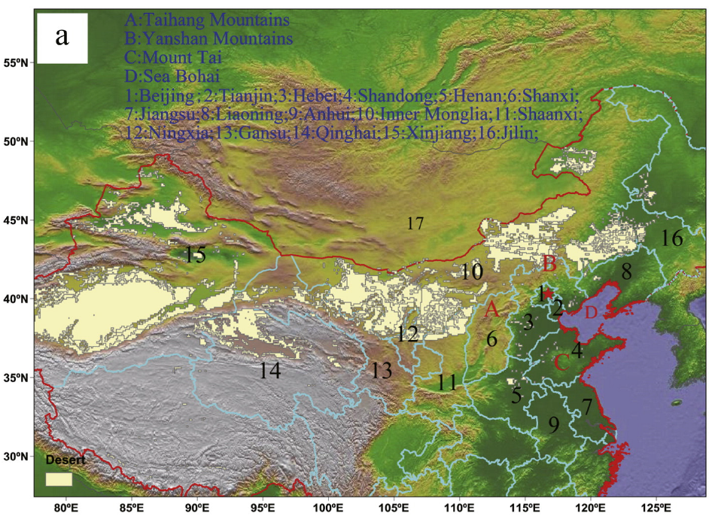

Figure : Topographical map of Beijing and surrounding regions Source:(Li et al., 2017).

## Air pollution data

### London

NO2 hourly mean mass concentration data for London were retrieved using the function “importKCL” from the R software package “Openair” (for documentation please refer to Carslaw and Ropkins, 2012). This function imports data from the LAQN’s archives as R data objects from remote servers operated from the King’s College London network. Air quality data were retrieved for Brixton road for January of the years between 2014 and 2018. Additional information is available in appendix 1.1.

### Beijing

PM10 hourly mean mass concentrations for 2017 were retrieved from Harvard Dataverse V1, originally provided by the Ministry of Environmental protection of China (“datacenter.mep,” n.d.; Wang, 2019). PM10 data for the years between 2016 and 2013 were retrieved from the Beijing Municipal Environmental Monitoring Centre3. Pollution data from both sources were retrieved for the urban background station of Aotizhongxin. Combining the two sources provided a dataset with 98.27% completeness.

Meteorological data

#### London

Due to the lack of complete information about wind speed, wind direction and air temperature data for Brixton road, pollution data from this station were paired with meteorological data from Marylebone road. This site was the closest station to Brixton road (5.4 miles) with a high degree of dataset completeness (98.27% ) and was deemed representative of the meteorological conditions in Brixton road. Meteorological data for Marylebone road were retrieved using the Openair function “importAURN”, which provides data from the Automatic Urban and Rural Network. This function operates in a similar manner to “importKCL”. Additional information about Marylebone road station is available in appendix 1.1.  
  
Beijing

As air quality stations in Beijing do not have records of meteorological observations, Air quality measurements were paired with meteorological information from the closest weather station from the China Meteorological Administration. PM10 data for Aotizhongxin station were coupled with meteorological data from Hadian station, additional details about the station coordinates are available in appendix 1.3.

## Wind analysis

To identify anomalies in wind speed, wind direction, and air pollutants concentrations, timeseries, wind roses and pollution roses were employed in this study. Local wind direction and air pollutants’ measurements were not associated due to the complicated influence of the urban environment on these parameters (dynamics of street canyon) which go beyond the purposes of this study.

### Timeseries

Time series of air pollutants concentration, wind speed, wind direction and ambient air temperature were created using Rstudio, for the scripts used, please refer to the URL: https://github.com/ceio1/Final-thesis-codes.git. Additional details about the software and version used are available in Appendix 1.4

### Wind roses

Mean wind speed and direction were examined using wind roses. This tool divides wind direction into sectors, interpolating wind speed, to illustrate the relative frequency of these parameters over a defined period (Carslaw and Ropkins, 2012) Wind roses were plotted to compare JF1 and JF2 to the climatology in London and November and December 2017 to the climatology in Beijing. The Zefir package in Igor Pro was used to plot Wind roses, additional details and version used are present in Appendix 1.4.

### Pollution roses

Pollution roses couple mean wind direction and air pollutants concentrations. These are similar to wind roses but wind speed is substituted for a pollutant concentration. Pollution roses were used to investigate anomalies in January 2018 (London) and November/December 2017 (Beijing) compared to the climatology. The Zefir package in Igor Pro was used to plot pollution roses, additional details and version used are present in Appendix 1.4.

## Trajectory analysis

### Meteorological data input – GDAS1

GDAS1 were used for computing air mass BT simulations in this study, retrieved from the ARL’s ftp server(“Air Resources Laboratory - GDAS Data Archive,” n.d.). The contain only certain meteorological fields considered most relevant for air pollutants’ transport and dispersion modelling in a synoptic time sequence (see appendix 1.5 for additional information)(“Air Resources Laboratory - GDAS Data Archive,” n.d.). GDAS1 files used had a spatial resolution of 1° latitude longitude and 3 hours temporal resolution(“Air Resources Laboratory - GDAS Data Archive,” n.d.).

### Back-trajectory generation

3-D five-day (120 hr) back-trajectories (BTs) were calculated using the package PySPLIT (Python) and the PC version of HYSPLIT (see appendix 1.4 for additional details about the software and visit the URL: <https://github.com/ceio1/Final-thesis-codes.git> for scripts)(Stein et al., 2015; Warner, 2018). Daily BTs were computed for the study periods at arrival times 03, 06, 09, 12, 15, 18, 21 and 0 UTC with source location London and Beijing (see appendix 1.6 for precise coordinates). The coordinates of BTs arrival destination were retrieved typing the name of source location in Google Earth (for information about the software version see appendix 1.4). These coordinates were deemed suitable to represent the arrival of air masses influencing the source locations. Arrival heights of BTs were set at 400m above ground level (AGL). Although measurement of air pollution is conducted close to the ground surface, the air above ground surface is well mixed, therefore an arrival altitude of 400 meters is assumed to be representative of their concentration at ground level (Kotthaus and Grimmond, 2018; Tang et al., 2016). BTs generated at low altitudes incur in errors due to the influence of the ground surface. To identify the arrival altitude at which this influence was minimal, a sensitivity analysis was performed by visually comparing the spatial difference between original BTs and their reverse trajectories (details are available in Appendix 1.7). This resulted in a height of 400m AGL. Furthermore, literature research revealed the Planet Boundary Layer (PBL) in winter in London and Beijing are expected to vary between 400 and 900 m and between 500 and 1000 m AGL, respectively. Setting source location arrival altitude at 400 m increased the likelihood that BT had travel paths likely below or just above the PBL (Kotthaus and Grimmond, 2018; Tang et al., 2016). There is uncertainty associated with the influence of atmospheric turbulence and convection on BTs arrival height, which is not easily quantifiable (Baker, 2010). However, employing 3-D trajectories, account for vertical movements, thus being defined as the most accurate trajectory type (Draxler, R.R., Hess, G.D., 1998, n.d.). The hours were chosen to take advantage of the maximum temporal resolution available for GDAS1 files (“Air Resources Laboratory - GDAS Data Archive,” n.d., p. 1).

### Trajectory errors

From the literature, the error associated with BT generated with HYSPLIT is generally between 15 – 30% of the travel distance. (HYSPLIT tut). For this study, a component of the error (integration error) was estimated performing a Forward/Backward test. This entailed generating a forward trajectory for each BT, which is initialised at the endpoint of the BT. The difference between the source location between the source location of the BT and the endpoint of their reverse trajectory is the integration error. BT with associated integration error higher than two standard deviation from the mean were not considered in the analysis, to minimize this error. For London 6.12% of the BT were discarded and 8.01% for Beijing. (GITHUB). Total trajectory error is assumed to be 20% of the travel distance of BTwhy?.

### BT clustering – need to explain better mean cluster

Clustering of BT is a procedure that involves the partition of BT into different sets, having same source location, similar trajectory paths and similar endpoint, represented by mean clusters (MC). This permits to neatly display numerous trajectories as one variable which is representative of the mean flow of those trajectories. MCs from JF1 and JF2 in 2018 were compared to MCs of JF1 and JF2 in climatology for London and MCs from November and December 2017 were compared to MCs in December and November in climatology The default HYSPLIT clustering algorithm was employed in this study (see appendix 1.8 for details)(Stein et al., 2015). As suggested by its developers, only natural clusters were employed. This resulted in 8 MC for JF1 2018, 8 MC for JF1 climatology, 7 MC for JF2 2018 and 7 for JF2 climatology in London. In Beijing, 7 MC were identified for November climatology, 9 MC for November 2017, 8 MC for December climatology, and 7 MC for December 2017. Additional details regarding the choice of clusters is available in Appendix 1.8. The resulting clusters have been classified according to origin location, travel path, and residence time, The latter inferred comparing the distance travelled between time intervals.

## Data manipulation

Calculations and manipulations of datasets were performed using Microsoft Excel and Rstudio software (see Appendix 1.4 for details). All data displayed are in Local time (GMT for London and GMT+8 for Beijing)

# Results and discussion

## London

### Time series analysis

Overall, NO2 concentrations exceeded the legal limit of 200 µg/m³ a total of thirteen times in January 2018 (6 in JF1 and 7 in JF2) and twenty-five times in January climatology (9 in JF1 and 16 in JF2). Observing A in Figure 3, it is evident that NO2 concentrations in 2018 were consistently below than in the climatology. Periods in which the difference persisted for an extended period was during January 6 to 10 , 15 to 18, 22 to 25 and 27 to 29 (A in figure 3). Between January 6 and 10, NO2 concentrations in 2018 were nearly 50% lower than in the climatology, and no exceedance of legal limits was recorded, but these were exceeded twice during the climatology. Between January 15 and January 18, NO2 levels were consistently higher in the climatology than in 2018, nearing 180 µg/m³ (A in Figure 3). During this period, NO2 legal limits were exceeded eleven times in the climatology compared to zero in 2018. Between January 19 and January 21, 2018, NO2 concentrations were substantially lower than in the climatology, and NO2 legal limits were exceeded only once during this period in 2018 compared to eight times in the climatology. Similarly, during January 23, 2018, limits were not exceeded in 2018 compared to three times in the climatology. During the January 28, 2018, NO2 concentration remained lower than the average (nearing 100 µg/m³ compared to 160 µg/m³) however, in both periods the legal limits were not exceeded.

South-westerly winds are predominant in this location during both periods examined. During the first five days of January 2018, the wind direction was south-westerly, similar to the climatology (B in Figure 3). However, during the early hours of January 6, a sudden change in wind direction was recorded. The wind shifted rapidly anticlockwise from south-westerly to north-easterly. This change in wind direction might indicate the passage of a cold front over this area, as steep decrease in air temperature and wind speed was also observed (C and D in Figure 3). North-easterly winds were predominant throughout January 6 and wind direction gradually shifted clockwise, from north-easterly to southerly during the following four days (B in Figure 3). Then, during the early morning of January 10 the wind rapidly shifted from north-easterly to south-easterly. During this period, NO2 concentrations were approximately 50% of the levels recorded for the climatology (A in Figure 3) and air temperature was consistently lower than in the climatology (1-5°C and 5-9°Crespectively). In 2018, Between January 10 and the early hours of January 12 the wind remained northerly. A sudden variation in wind directions was recorded on January 12 (from northerly to south-easterly) and this change in wind direction remained constant throughout January 14. During this period, a slight drop in wind speed was observed, corresponding with a drop in air temperature and NO2 levels (A, C and D in Figure 3). Between January 15 and January 19, wind direction was similar in the compared periods. However, the wind speed in 2018 was considerably higher than in the climatology, often peaking at values three times higher (4-9 m/s compared to 2-3 m/s). Between January 23 and January 25 legal NO2 limits were exceeded four times in the climatology and zero times in 2018. No difference in wind direction was recorded between 2018 and the climatology during this time. However, a peak in wind speed and air temperature was observed was observed in 2018 (C and D in Figure 3). Lastly, during January 28, the prevalent wind was north-westerly, with higher wind speed and air temperature in 2018 than in the climatology. Periods in 2018 associated with NO2 concentrations lower than in the climatology, loosely coincide with periods during which wind speeds were observed to be higher than the climatology. High wind speeds are often associated with dispersion of NO2 in an urban environment, while calm and stable conditions increase the likelihood of accumulation (Grundström et al., 2015; Shi and Harrison, 1997). This might explain the trend observed in 2018. Overall, January 2018 appears to be anomalous, with consistently lower NO2concentrations than the average, higher wind speeds and sudden shifts in wind direction, which are not recorded in the climatology. Although variations in meteorological parameters in the climatology would be less evident due to averaging of observations, changes of significant amplitude are observed in 2018. To investigate further the anomalies recorded in meteorological conditions, the average and standard deviations of observed meteorological variables were calculated and are present in table 1.

|  |  |  |  |  |  |  |
| --- | --- | --- | --- | --- | --- | --- |
| **Period** | **Average wind speed (m/s)** | **Standard deviation (wind speed)** | **Average wind direction (****°)** | **Standard deviation (wind direction)** | **Air temperature (°C)** | **Standard deviation (air temperature)** |
| JF1 | 3.84 | ± 2.04 | 179.60 | ± 96.69 | 4.68 | ± 2.49 |
| JF1 climatology | 4.37 | ± 0.98 | 235.47 | ± 37.08 | 6.10 | ± 1.56 |
| JF2 | 4.24 | ± 2.04 | 253.25 | ± 44.25 | 5.43 | ± 3.53 |
| JF2 average | 3.16 | ± 0.97 | 197.69 | ± 37.91 | 3.49 | ± 2.09 |
| **Average total** | 3.90 | ± 1.20 | 216.50 | ± 43.18 | 4.92 | ± 1.93 |

**Table 1: Averages of wind speed, wind direction and air temperature in London during January periods.**

Average air temperature in JF1 was lower than in the average of the climatology, whereas in JF2 it was consistently higher (Table 1). It is also evident from the standard deviation that JF2 2018 was the period with greatest variability. To aid the interpretation of the next section, wind speed ranges were classified in nearly average, above average, and high (Table 2) based on the total average from table 1. Similarly, average, and standard deviations of NO2 concentrations were calculated and are presented in Table 3. NO2 concentrations were also divided in ranges and classified according to average concentrations observed during the study periods (Table 3) and European limits. The classification is presented in table 4.

|  |  |
| --- | --- |
| **Wind speed** | **Classification** |
| < 4 m/s | Nearly average |
| Between 4 and 8 m/s | Above average |
| > 8 m/s | High |

**Table 2: Wind speed ranges and classification**

|  |  |  |
| --- | --- | --- |
| **Period** | **Average NO2 concentration (µg/m³)** | **Standard deviation (NO2 concentration)** |
| JF1 | 88.37 | 45.06 |
| JF1 climatology | 126.91 | 47.18 |
| JF2 | 105.15 | 47.45 |
| JF2 climatology | 132.41 | 41.56 |
| **Average total** | 113.21 | 45.31 |

**Table 3: NO2 average concentrations during the study periods and standard deviation.**

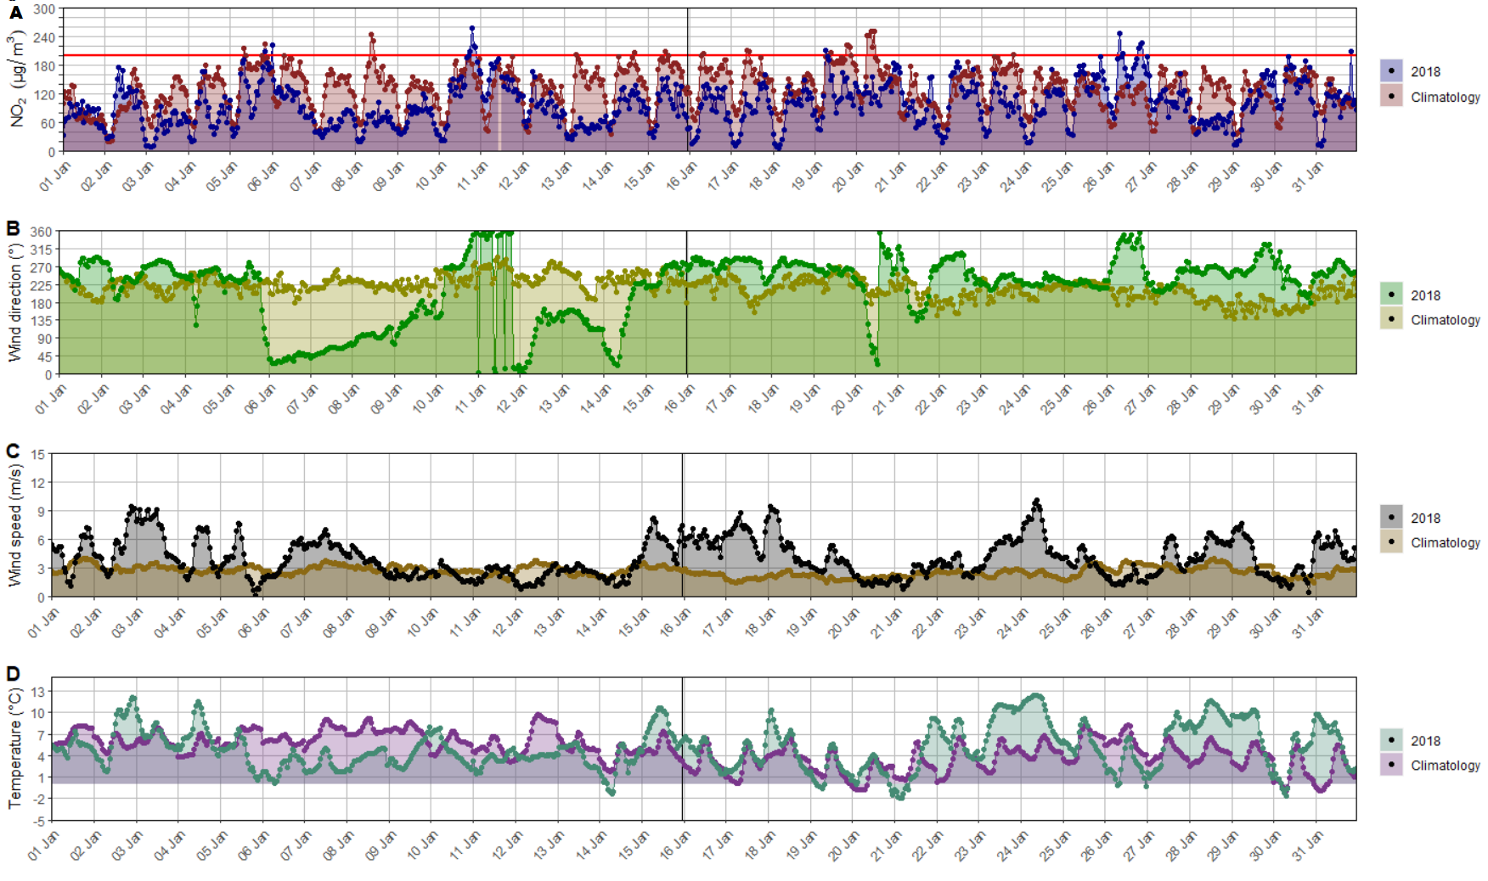

Figure 3: Time series of NO2 concentration (A), Wind direction (B), Wind speed (C) and Ambient air temperature (D) during January 2018 and in January climatology in London. The horizontal red line in A represents the EU legal limit for NO2 concentration.

**Table 4: NO2 concentration ranges and classification**

|  |  |  |
| --- | --- | --- |
| **NO2 concentration (µg/m³)** | **Classification** | **Comparison to EU limits (200 µg/m³)** |
| <120 | Nearly average | Below limits |
| Between 120 and 180 | Above average | Within limits |
| >180 | High | Nearing limits |

### Local Wind and NO2 concentration analysis

In JF1 climatology, Westerly and south-westerly winds were predominant (35% westerly and 31% west-south-westerly respectively) (Figure 4 top). Southerly and, and south-easterly were recorded with minor frequency (12% south-southwesterly, 8% southerly and 8% south-southeasterly respectively). Wind speeds above the average were recorded most frequently (21% when westerly 23% when south-westerly, 8% when south-southwesterly, 8% when southerly and 4% when south-southeasterly). Nearly average wind speeds were uncommon (24%) and high wind speeds where not recorded. IN JF1 2018, westerly and south westerly were also dominant, but recorded with less frequency than in JF1 climatology (19% and 17% respectively). Differently from JF1 climatology, north-easterly and easterly winds were recorded, while south-easterly winds occurred more frequently (11%). Wind speed nearly average were more common in JF1 2018 than in JF1 climatology (55%). Differently from the climatology, high wind speeds in 2018 were observed (5%). In JF2 climatology, south-westerlies were predominant (28% for west-southwesterly and 26% for south-southwesterly) and southerly south-easterly were common (16% southerly and 23% south-southeasterly). Wind speed was mostly nearly average (73%) and wind speeds above the average were uncommon (20%). High wind speeds were not recorded, as well as observations of wind direction in the northerly and easterly section. In JF2 2018 westerly and south westerly winds were dominant (35% westerly, 29% west-southwesterly and 11% south-southwesterly), north-westerly occurred rarely (12% west-northwesterly and 4% north-northwesterly) and no other direction was observed. Wind speed was mostly above average (50%), nearly average in 45% of the observations and rarely high (5%). Overall, high winds occurred only in 2018, and above average wind speeds occurred more frequently than in the climatology. JF1 2018 had higher variability in wind direction than JF1, with occurrences of winds between 315° and 135° which did not occur in climatology. westerly and south-westerly winds were prevalent in JF2 2018, while in JF2 climatology were south westerly and southerly. High NO2 concentrations occurred more frequently in JF1 and JF2 climatology (9% and 11%) than in 2018 (4% JF1 and 2% in JF2)( Figure 4 bottom). Above average NO2 concentrations were also substantially higher in climatology than in 2018 (43% in JF1 and 53% in JF2 climatology and 19% in JF11 and 28% in JF2). Although similar studies in this location during the study period were not available, the results for the climatology had a similar general trend to (Jeanjean et al., 2017).

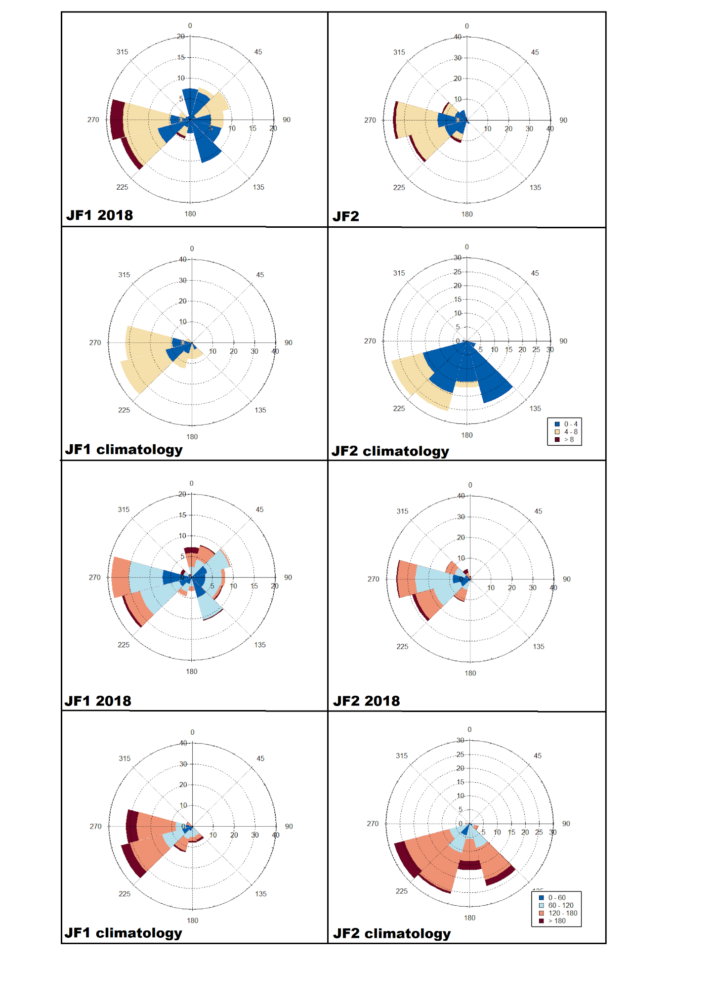

Figure 4: Wind roses (above) and pollution roses (below) for the period studied in January for London.

## Trajectory analysis

### Air masses affecting London during study times

The results of the cluster analysis are present in Table 5, Figure 5, and Figure 6.

**Table 5: Results of the cluster analysis, including classifications according to mean NO2 concentrations and Relative frequency by direction and type for London.**

|  |  |  |  |  |  |  |
| --- | --- | --- | --- | --- | --- | --- |
| **Period** | **Cluster number** | **Direction and type** | **Relative frequency (%)** | **Classification according to mean NO2 concentrations** | **Relative frequency by mean PM2.5 classification levels** | **Relative frequency by direction and type (%)** |
| JF1 2018 | MC1 | W fast | 15 | Nearly average | Nearly average: 100 | W fast :28 |
|  | MC2 | NW fast | 14 | Nearly average |  | NW fast: 14 |
|  | MC3 | W fast | 13 | Nearly average |  | NE slow: 12 |
|  | MC4 | NE slow | 12 | Nearly average |  | SW fast: 6 |
|  | MC5 | SW fast | 6 | Nearly average |  | SE slow (recirculated): 25 |
|  | MC6 | SE slow (recirculated) | 25 | Nearly average |  | W fast (recirculated): 9 |
|  | MC7 | W fast (recirculated) | 9 | Nearly average |  | S fast: 5 |
|  | MC8 | S fast | 5 | Nearly average |  |  |
| JF1 climatology | MC1 | W fast | 16 | Above average | Above average: 59 | W fast :34 |
|  | MC2 | W fast | 18 | Above average | Nearly average:41 | NW fast: 35 |
|  | MC3 | NW fast | 18 | Nearly average |  | SW slow: 15 |
|  | MC4 | SW slow | 15 | Nearly average |  | SE slow (recirculated): 6 |
|  | MC5 | NW fast | 17 | Above average |  | SW fast: 2 |
|  | MC6 | SE slow (recirculated) | 6 | Nearly average |  | NE fast: 8 |
|  | MC7 | SW fast | 2 | Nearly average |  |  |
|  | MC8 | NE fast | 8 | Above average |  |  |
| JF2 2018 | MC1 | W fast | 26 | Nearly average | Nearly average:77 | W fast: 39 |
|  | MC2 | NW fast | 13 | Nearly average | Above average:23 | NW fast: 36 |
|  | MC3 | NW fast | 13 | Above average |  | SW slow: 15 |
|  | MC4 | W fast | 13 | Nearly average |  | SW fast: 10 |
|  | MC5 | NW fast | 10 | Above average |  |  |
|  | MC6 | SW slow | 15 | Nearly average |  |  |
|  | MC7 | SW fast | 10 | Nearly average |  |  |
| JF2 Climatology | MC1 | SW fast | 10 | Nearly average | Above average:46% | SW fast: 10 |
|  | MC2 | W fast | 23 | Above average | Nearlt average:37 | W fast: 23 |
|  | MC3 | N slow | 13 | Above average | High:7 | N slow: 13 |
|  | MC4 | NW slow (recirculated) | 13 | Nearly average |  | NW slow (recirculated): 13 |
|  | MC5 | SE slow (recirculated) | 24 | Nearly average |  | SE slow (recirculated): 24 |
|  | MC6 | NW fast | 10 | Above average |  | NW fast: 10 |
|  | MC7 | NE fast | 7 | High |  | NE fast: 7 |

IN JF1 climatology, westerly fast (MC1 and MC2) and north-westerly fast (MC3 and MC5) air masses were prevalent (34% and 35%). South-westerly slow (MC4) and north-easterly fast (MC8) air masses were uncommon (15% and 8%). South-easterly slow recirculated (MC6) and south-westerly fast (MC7) air masses affected London with minimal frequency (6% and 2%)(Figure 5 and Table 5).

IN JF1 2018, westerly fast (MC1 and MC3) and south-easterly slow recirculated (MC6) air masses were dominant (28% and 25%). North-westerly fast (MC2) and north-easterly slow (MC4) air masses had similar frequency (14% and 12%), with westerly fast recirculated (MC7), south-westerly fast (MC5) and southerly fast (MC8) air masses observed with minimal frequency (9%, 6% and 5%) (Figure 5 and Table 5).

IN JF2 climatology, south-easterly slow recirculated (MC5) and westerly fast air masses (MC2) were prevalent and occurred with similar frequency (24% and 23%). Northerly slow (MC3) and north-westerly slow recirculated (MC4) air masses occurred with similar frequency (13% and 13%) as well as south-westerly fast (MC1) and north-westerly fast MC6) ( (10% and 10%). North-easterly fast (MC6) air masses occurred in minimal proportion (7%)(Figure 5 and Table 5).

IN JF2 2018, westerly fast (MC1 and MC4) and north-westerly fast (MC 2, MC3 and MC5) air masses were dominant (39% and 36%). South-westerly slow (MC6) and south-westerly fast (MC7) air masses occurred less often (15% and 10%). Although studies for similar locations and times were not found, the general trends observed in the climatology of this study are similar to previous cluster analysis performed in the British Isles during winter (Donnelly et al., 2015).

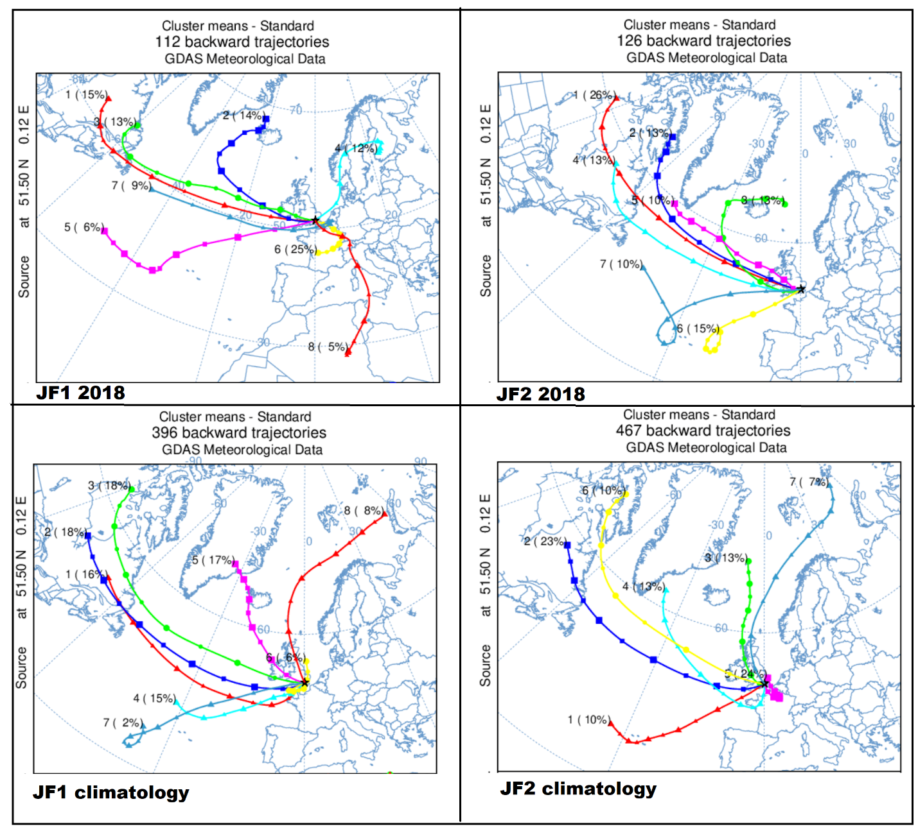

Figure 5: Panel depicting the MCs for January of the study periods. The source locations and total number of Bts clustered for each period are displayed on the individual figures.

#### JF1

Westerly air masses affected London slightly less frequently in climatology than in 2018 (34% and 37%), while north-westerly air masses were less common during 2018 than in the climatology (14% and 35%). South-easterly recirculated air masses occurred four times more frequently in 2018 than in the climatology (25% and 6%), while north-easterly air masses were slightly more frequent in 2018 than in the climatology (12% and 8%). Southerly air masses were only recorded in 2018 (5%)(Figure 5 and Table 5).

JF2  
  
In JF2 2018 Westerly air masses were more common in 2018 than in climatology (39% and 23%) as well as North-westerly air masses (36% and 23%). South-westerly air masses were also more common in

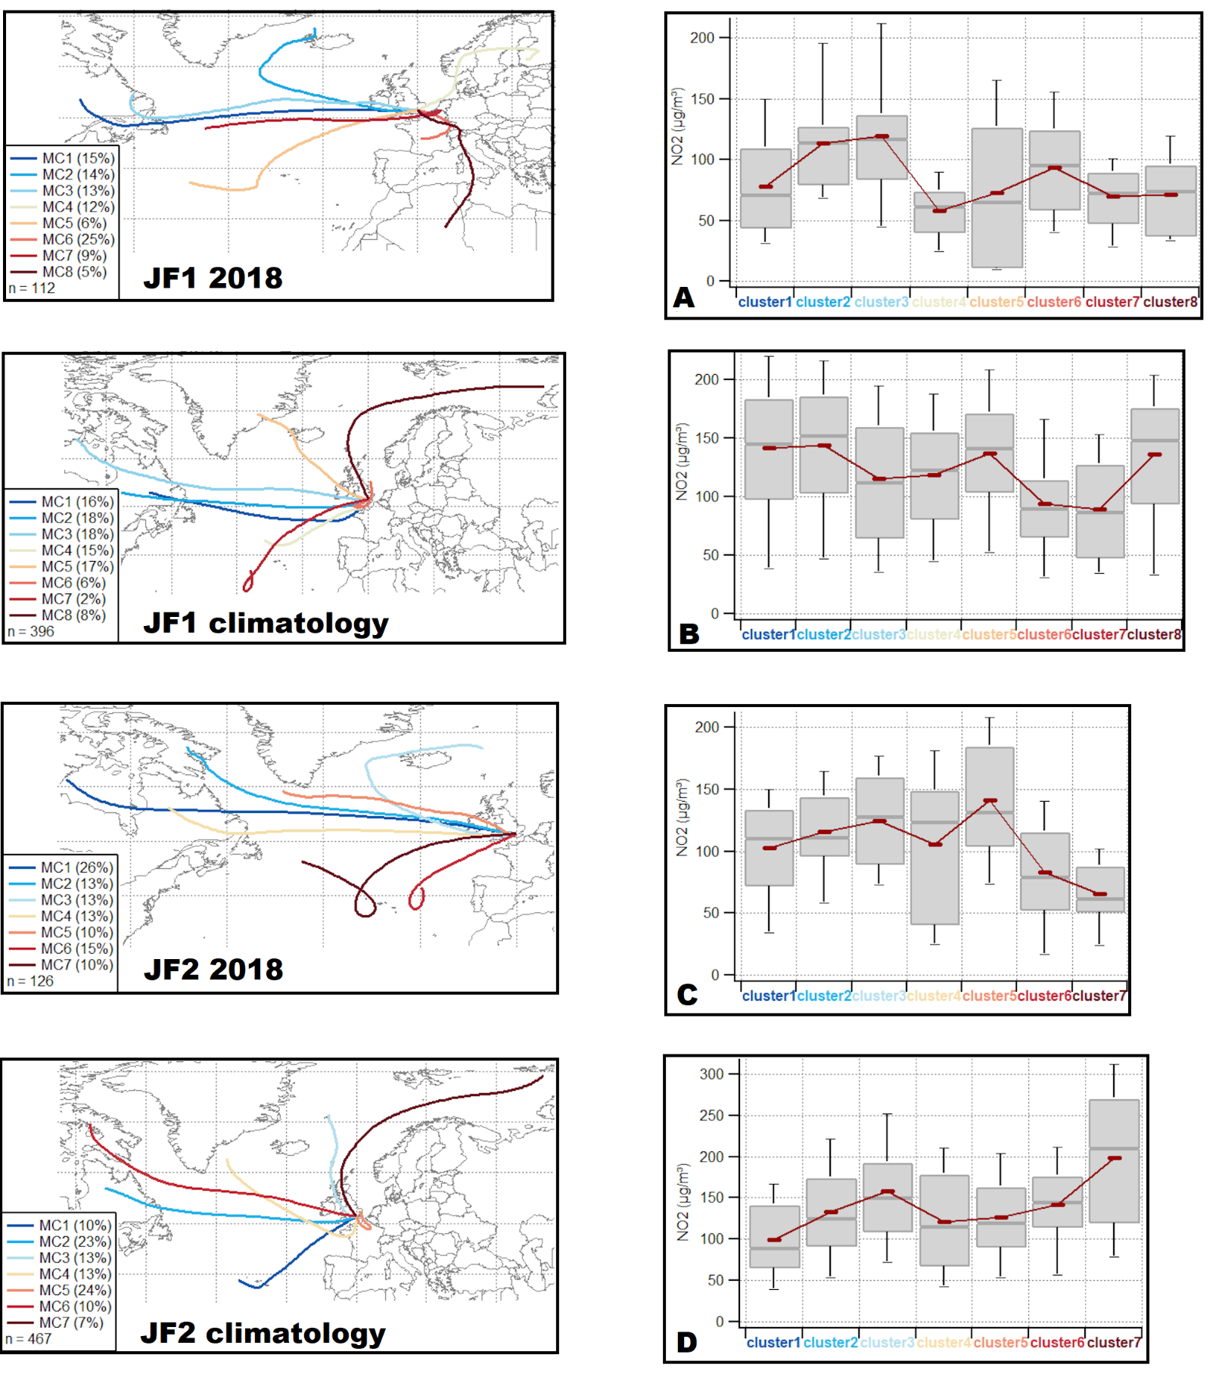

Figure 6: MC relative frequency (left) and mean NO2 levels associated with each MC (right) for London in the study periods.

2018 than in climatology (25% and 10%). In climatology, three new types of air masses are identified compared to 2018: northerly fast, northerly slow and south easterly slow recirculated. Overall, these air masses accounted for 44% of the total air masses arriving in London(Figure 5 and Table 5).

COMPARISON

### Residence time and NO2 concentrations

#### JF1

In 2018 air masses had a shorter ground tracks over UK land than in the climatology (Figure 5 and Figure 6 A-B). In climatology, MC8 and MC5 are associated with some of the highest NO2 mean concentrations (Figure 6 B). Air masses with similar paths to these clusters are usually associated with low pollutants concentrations (Northerly Arctic maritime and polar continental)(Donnelly et al., 2015). However, during the last section of their travel paths, these MCs have the longest ground track over the UK than any other MC observed in this period (Figure 5 and 6). MC5 originates in Greenland and travels over the north Atlantic intercepting West midlands and the southern part of England’s North West on its path (Figure 5). MC8 originates in the Barents Sea and travels towards Iceland to steer SE towards the north of Scotland (Figure 5). In the last 24h before reaching London, air masses associated with these clusters travel over Liverpool and Birmingham (Figure 5). These areas are urban and industrial, where NO2 emissions are intense, due to transportation and industrial heating. Due to the travel path over these areas during, it is likely that air masses associated with MC5 and MC8 likely captured NO2 pollution and transport it to London. Consistent with this finding, (Pope et al., 2014) found high values of composite NO2 ozone monitoring instrument columns in winter over the urban areas of West Midlands and the southern part of the North West of England. The relative frequency of mean clusters travelling through these major urban and industrial centres of the UK is one quarter of total air masses in climatology (25%), while no MC was observed to have similar travel paths in 2018 (Figure 5 and figure 6). MC1 and MC2 in climatology are also associated with above averagemean NO2 concentrations while MC7 is associated with the lowest mean NO2 concentrations (Figure 6 B). Air masses from this cluster are associated with Tropical maritime air masses, which are usually associated with clean air from the Atlantic Ocean (Baker, 2010; Donnelly et al., 2015). MC6 does not intercept any major urban area prior to arrival to London. This explains its association with the lowest NO2 concentrations in the climatology. MCs associated with this type of air mass were rare in the climatology (MC7, 2%), but occurred more frequently in 2018 (MC5, 6%) (Figure 6 A-B). South-easterly recirculated air masses (MC6 in both 2018 and climatology) were also associated with low levels of NO2 mean concentration. These MCs recirculate over the North Sea and travels on the English Channel, with limited ground track before reaching London (Figure 5). These areas are generally well ventilated in winter, and the absence of ground track decreases the likelihood for air masses associated to this cluster to transport NO2 pollution to London (REEF).These occurred rarely in JF1 climatology (6%) and were common in JF1 (25%). In JF1 2018, all MCs (100%) were associated with nearly average mean NO2 concentrations, while in JF1 climatology, MCs associated with above average concentrations (58%) occurred more frequently than MCs with nearly average concentrations (41%)(Figure 6 and Table 5).

Generally, MCs in JF1 2018 had lower mean NO2 concentrations than in JF1 climatology. This was partly due to a reduction in London’s local pollution in 2018, hence air masses travelling through London to source location in 2018 transported a lower NO2 concentration than in the climatology (LAMBETH). Furthermore, the lower relative frequency of MCs associated with short ground track over the urban areas of the West midlands and southern North West of England during 2018 is the likely cause of this finding. This is reflected in the higher proportion of MCs with above average No2 mean levels in climatology (41%) than in 2018 (0%).

#### JF2

MCs associated with tropical maritime air masses, with nearly average NO2 concentrations were more frequent in 2018 (MC6 and MC7, 25% of total air masses) than in the climatology (MC 1, 10% of total air masses) (Table 5). Polar maritime air masses in 2018 were mainly associated with nearly average NO2 concentrations ( MC 2, 1 and 4, 53% relative frequency) with minor occurrence of MCs associated with above average concentrations (MC5, 10%) (Table 5). Conversely in climatology, MCs associated with polar maritime air masses with above average mean NO2 concentrations were common in climatology (MC6 and MC2, 33% relative frequency) (Table 5). It is likely that local NO2 emissions in London were greater during the climatology than in 2018. Therefore, MCs usually associated with air masses transporting uncontaminated air (such as MC6 and MC2) are associated with relatively high NO2 concentrations. MCs associated with Returning polar maritime air masses, in turn related with above average concentrations in 2018 (MC3) and nearly average in climatology (MC4) occurred with similar frequency in both periods (both 13%). Although the additional cluster identified in climatology had low frequency (MC7, 7%), it was associated with high NO2 mean levels (Table 5, Figure 6 D). Additionally in the climatology, MC3, (arctic maritime) which is usually linked to pure air, was associated with above average mean NO2 concentrations in the climatology (Table 5, Figure 6D). This phenomenon likely occurred due to the extended ground path over the urban and industrial areas of the North West and West Midlands as described above. The south-easterly recirculated air mass (MC5) was common in 2018 (24%), with nearly average concentrations. In climatology, MC6 (analogous to MC5 in 2018, was associated with above average NO2 mean concentrations. This is likely due to higher local emissions of NO2, which have been captured and transported in the last section of travel path before reaching London, thus contributing a higher concentration than in 2018, when local emissions were lower. Overall, a higher proportion of MCs in the climatology were associated with high and above average NO2 levels than in 2018 (Table 5, Figure 6 A, B, C, D). MC with high and above average mean NO2 concentrations had higher relative frequency in climatology than in 2018 due to the reasons described above. This partly explains the lower NO2 concentrations in London during January 2018 than in the climatology.In JF2 2018, most MCs had NO2 mean concentrations nearly average (77%) and the remainder were associated with above average concentrations (23%) (Table 5). IN JF2 climatology, MCs with nearly average concentrations (47%) and above average concentrations (46%) occurred with similar frequency, but MCs with above average concentration occurred more frequently than in 2017 (Table 5). Furthermore, a cluster with high concentrations of mean NO2 concentration was observed (MC7), with a frequency of 7% (Table 5).

Similarly, to JF1, but less dramatically, the proportion of clusters associated with nearly average mean NO2 concentrations is higher in 2018 (77%) than in climatology. This is due both to a reduction in local emissions in 2018 and a lower frequency of MCs with ground track over regional areas with high NO2 levels.

## Beijing

### Difference in meteorological conditions and PM2.5 concentration

In 2017, 24-h mean PM2.5 concentrations were substantially lower in 2017 than in the climatology (Figure 9). In 2017, PM2.5 levels exceeded the WHO organisation limits a total of 42 times (25 in November and 17 in December) while during the climatology, this limit was exceeded 61 times (30 in November and 31 in December) respectively (Figure 9). The average PM2.5 levels of the periods studied are reported in table 6. In 2017 PM2.5 concentrations decreased by 54% in November and by 62% in December compared to the climatology (Table 6).

**Table 6: Table depicting Average PM 2.5 and standard deviation during the period studied**

|  |  |  |
| --- | --- | --- |
| **Period** | **Average PM2.5 concentration (µg/m³)** | **Standard deviation (Average PM2.5 concentration)** |
| November 2017 | 45.51 | 38.05 |
| December 2017 | 43.63 | 43.76 |
| November climatology | 98.45 | 32.35 |
| December climatology | 115.32 | 54.58 |
| **Average total** | 75.73 | 42.18 |

**Table 7: Table depicting Average wind speed and standard deviation during the period studied**

|  |  |  |
| --- | --- | --- |
| **Period** | **Average wind speed (m/s)** | **Standard deviation (Average wind speed)** |
| November 2017 | 1.44 | 1.09 |
| December 2017 | 1.51 | 0.62 |
| November climatology | 1.65 | 1.09 |
| December climatology | 1.75 | 0.72 |
| **Average total** | 1.59 | 0.88 |

As to London, Averages and standard deviations of wind speed during the study periods were calculated and are presented in Table 7. Wind speed ranges (Table 8) and mean PM2.5 categories were also identified for Beijing (Table 9).Although wind speed was slightly higher in the climatology of November and December than in 2017, (by 4.6% for November and 6.2% in December) standard deviation values in 2017 are considerably higher than the climatology (by 75.4% in November 2017 and 51.7% in December), (Table 7). This indicates that wind speed in 2018 had considerably higher variability for November and December. To further investigate this variability, wind roses are compared using wind speed categories defined in Table 8 (Figure 9).

**Table 8: Table of classification of wind speed ranges**

|  |  |
| --- | --- |
| **Wind speed (m/s)** | **Classification** |
| < 2 m/s | Nearly average |
| Between 2 and 4 m/s | Above average |
| > 4 m/s | High |

**Table 9 Classification of PM2.5 concentration ranges.**

|  |  |  |
| --- | --- | --- |
| **PM 2.5 concentration( µg/m³)** | **Classification** | **Comparison with WHO limits** |
| <75 | Nearly Average | Three times WHO limits |
| Between 75 and 150 | High | Twice to six times WHO limits |
| >150 | Extreme | More than 6 times WHO limits |

In November climatology, nearly average wind speed was prevalent (71%), with above average wind speeds occurring less frequently (29%). Although, recorded less frequently than in climatology, in 2017, nearly average wind speeds were dominant (65%), with above average wind speeds occurring with similar frequency to the climatology (30%) (Figure 10 top). Contrarily to the climatology, high wind speeds were recorded in November 2017 (5%). In November climatology, southeasterly winds were dominant (22% south-southeasterlies and 14% easterly-southeasterlies), with southerlies, southeasterlies and easterlies occurring less often (16%, 25% and 12% respectively). Northeasterly were rare (11%) (Figure 10 top). Conversely, in November 2017, Northeasterlies were dominant (26% north-northeasterly and 10% easterly-northeasterly), with common northerlies and north-westerlies (16% and 15%). South-westerlies and southerly were recorded with minimal frequency (16% and 5%) (Figure 10 top). In December climatology, nearly average wind speeds were dominant (61%) and above average were less common (39%). In December 2017, nearly average wind speeds were also predominant (65%), and above average were common (30%), with minimal occurrence of high wind speeds (5%) (Figure 10 top). In December climatology, there was a similar frequency of south-westerlies, and south-easterlies (28% and 28%), with common southerlies (17%), uncommon north-easterlies (9%) and minimal occurrence of easterlies and westerlies (6% and 2% respectively) (Figure 10 top). In December 2017, north-easterlies (30%) and north-westerlies (25%) were dominant , with common occurrence of south-westerlies (21%). Northerlies and westerlies were rare (11% and 5%) (Figure 10 top). From the pollution roses it is evident that PM2.5 concentrations nearly average were more frequent in November 2017 than in the climatology (67% and 26%)(Figure 10 bottom). Conversely, above average, and extreme PM2.5 concentrations occurred more frequently in November climatology (55% and 15%) than in 2017 (13% and 5%) (Figure 10 bottom). Similarly, nearly average concentrations were more common in December 2017 than in the climatology (67% and 26% respectively). High and extreme concentrations were also more frequent in December climatology (40% and 11%) than in December 2017( 23% and 4% respectively). It appears that higher wind speeds and lower levels of mean PM2.5 occurred in 2017 when compared to the climatology. This result is consistent with doi:10.1016/j.atmosenv.2016.03.047 good for PM 2.5 sources, which reports of

### Trajectory analysis

#### Air masses affecting Beijing in November and December

In Both periods of 2017, fast north-westerly air masses had higher relative frequency in 2017 than in the climatology (73% and 55% in November), particularly in December (76% in 2017 and 42% in the climatology) (Table 10). Slow air masses were more common in November climatology than in November 2017 (45% and 28% respectively). In November 2017, a different air mass type was identified (MC8 northerly slow recirculated), which had minimal relative frequency (6%) (Figure 11 and Figure 12). In December climatology, slightly different air masses affected Beijing, with slow air masses were more frequent in the climatology (44%) than in 2017 (10%). In The climatology, an additional air mass type was identified, different from 2017 (North-Easterly MC8). Northerly air masses had similar relative frequency in December 2017 (13%) and December climatology (2017), and both were fast. In November climatology, the dominant air masses were north-westerly fast (MC3, MC4, MC5, MC6 and MC7), which were 55% of the total air masses arriving in Beijing.

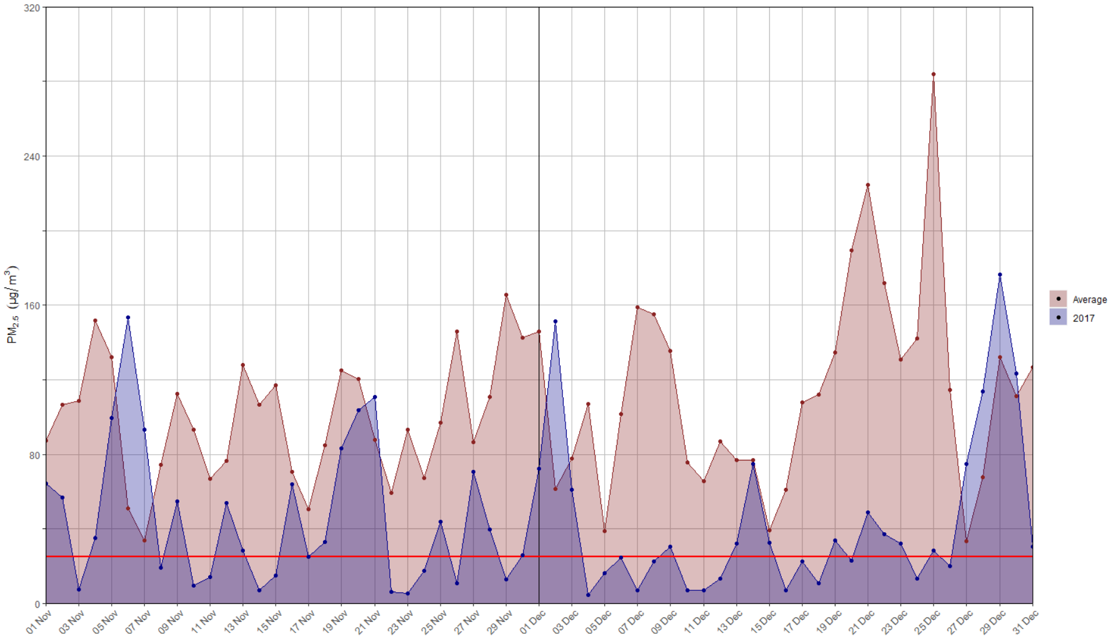

Figure 9: timelines of average 24h-mean PM 2.5 concentration in Beijing. The red line indicates the WHO PM2.5 legal limit of 25 µg/m³.

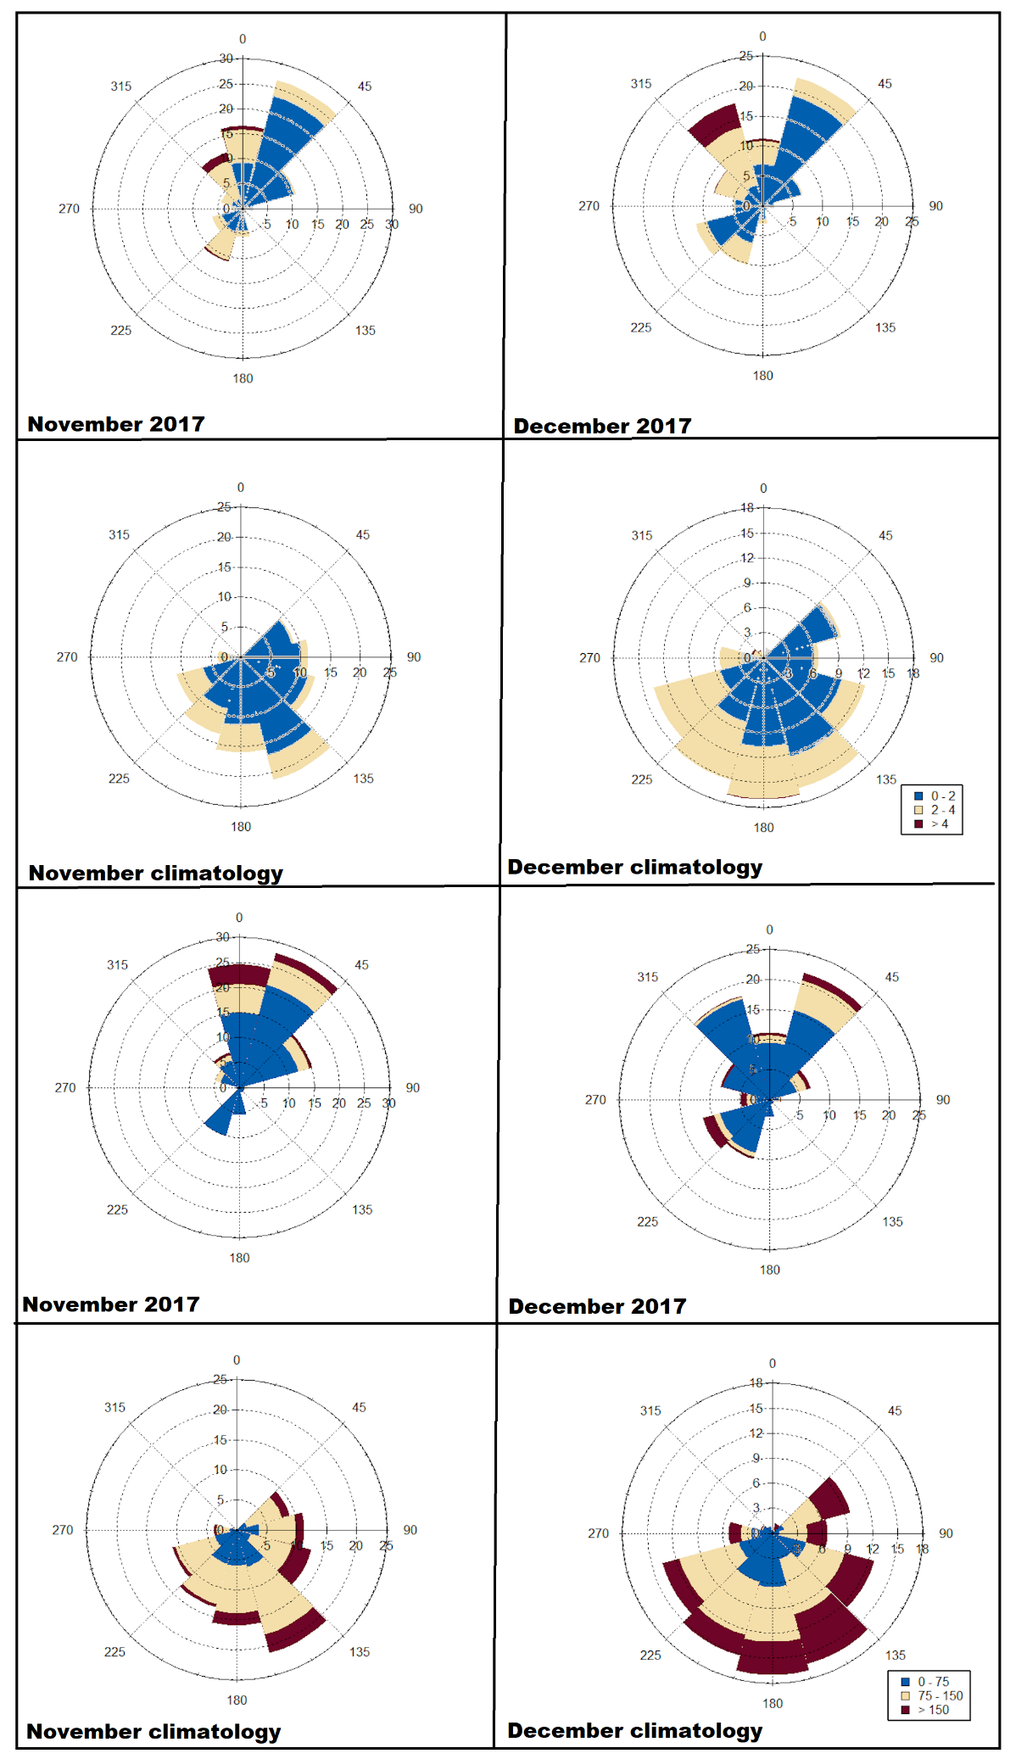

Figure 10: wind roses (top 4) and pollution roses (bottom 4) for November and December 2017 and climatology in Beijing.

|  |  |  |  |  |  |
| --- | --- | --- | --- | --- | --- |
| **Period** | **Cluster number** | **Direction and type** | **Relative frequency** | **Classification according to mean PM2.5 concentrations** | **Relative frequency by direction and type** |
| November 2017 | MC1 | NW slow | 11% | High | NW slow 22 |
| MC2 | NW fast | 18% | Nearly average | NW fast:73 |
| MC3 | NW fast | 14% | Nearly average | N slow (recirculated):6 |
| MC4 | NW fast | 9% | Nearly average |
| MC5 | NW slow | 11% | Nearly average |
| MC6 | NW fast | 16% | Nearly average |
| MC7 | NW fast | 15% | Nearly average |
| MC8 | N slow (recirculated) | 6% | High |
| MC9 | NW fast | 1% | Nearly average |
| November Climatology | MC1 | NW slow | 28% | High | NW slow: 65 |
| MC2 | NW slow | 17% | Extreme | NW fast:35 |
| MC3 | NW slow | 20% | High |
| MC4 | NW fast | 13% | High |
| MC5 | NW fast | 11% | High |
| MC6 | NW fast | 8% | Nearly average |
| MC7 | NW fast | 3% | Nearly average |
| December 2017 | MC1 | NW fast | 17 | Nearly average | NW fast 76 |
| MC2 | NW fast | 4 | Nearly average | NW slow (recirculated) 10 |
| MC3 | NW slow (recirculated) | 10 | High | N fast14 |
| MC4 | NW fast | 18 | Nearly average |
| MC5 | NW fast | 23 | Nearly average |
| MC6 | NW fast | 14 | Nearly average |
| MC7 | N fast | 14 | Nearly average |
| December climatology | MC1 | NW fast | 19% | Nearly average | NW fast 42 |
| MC2 | NW fast | 2% | Nearly average | Nw slow 34 |
| MC3 | NW slow | 17% | High | N fast 13 |
| MC4 | NW fast | 15% | Extreme | NE slow 10 |
| MC5 | NW slow | 17% | Extreme |
| MC6 | NW fast | 6% | High |
| MC7 | Nfast | 13% | Nearly average |
| MC8 | NE slow | 10% | Nearly average |

The remainder 44% were north-westerly slow air masses (MC1, MC2). In November 2017, north-westerly air masses were the majority (73%) of the air masses ( MC2, MC3, MC4, MC6, MC7 and MC9). North-westerly slow and northerly slow recirculated air masses contributed namely 22% and 6% of the air masses for this period. In December climatology, the prevalent air masses were north-westerly fast (MC1, MC2, MC4 and MC6), which made up 42% of the total air masses. North-westerly slow air masses (MC3, MC5), occurred in of the cases 34%. Northerly fast (MC7) and north-easterly slow (MC8), were observed to account for 13% and 10% of the total occurrences, respectively. In December 2017, north-westerly fast air masses were observed in 76% of the cases (MC1, MC2, MC4, MC5 and MC6). Northerly fast (MC7) and north-westerly slow (MC3) contributed namely 14% and 10% of the total air masses.

**Table 10: Results of the cluster analysis, including classifications according to mean NO2 concentrations and Relative frequency by direction and type for Beijing.**

Residence time, travel path and mean PM2.5 MC concentrations

November

In climatology, MCs associated with high mean concentrations of PM2.5 had the highest relative frequency (72% given by MC1, MC3, MC4 and MC5)(Figure 12 B). Extreme mean PM2.5 concentrations were uncommon (17% MC2), and 11% of the MCs were associated with nearly average PM2.5 concentrations (MC6 and MC7) (Figure 12 B).

In 2017, most MCs were associated with nearly average mean PM2.5 concentrations (84% given by MC2, MC3, MC4, MC5, MC6, MC7 and MC9), while MCs with high concentrations were uncommon (MC1, 11% and MC8, 6%) (Figure 12 B).

In climatology, MC2 (17% relative frequency) was associated with the highest mean PM2.5 concentration (extreme). Air masses associated with MC2 travelled through some of the most industrialised areas surrounding Beijing (Shanxi, Shaanxi and Hebei) (Figure 11-12). The long permanence time and travel path of this cluster over these areas might justify its association with extreme mean PM2.5 concentration (Figure 11). In November 2017, MC1 and MC8 have similar travel paths than MC2 in November climatology (Figure 11-12). However, the mean PM2.5 concentrations associated with MC1 and MC8 are lower than those associated with MC2 (high). Their relative frequency is similar in both periods (17% for MC2 in climatology, 11% for MC1 and 6% for MC8 in 2017).

In climatology, MC4 (13%) and MC5 (11%) are associated with high mean PM2.5 concentrations and have similar paths (Figure 11-12 D). These originate in south-western Russia and southern Russia respectively, travelling through Mongolia (and Kazakhstan for MC4), inner Mongolia and the Hebei province before reaching Beijing. MC2 and MC3 (nearly average) in 2017 are analogous to MC4 and MC5 in climatology but are associated with approximately half mean PM2.5 concentrations than MC4 and MC5 (high) in climatology (Figure 12 A-B). This difference might indicate a reduction of the emissions in the provinces intercepted during 2017, thus the lower contribution. MC5 and MC9 in 2017 and MC6 and MC7 in climatology are associated with the lowest mean concentrations of PM2.5 (nearly average). These are associated with the Siberian airmass, which brings clean air. In both periods, they have similar contributions towards total air masses (11% and 1% for MC5 and MC9 in 2017 and 8% and 3% for MC6 and MC7 in climatology).

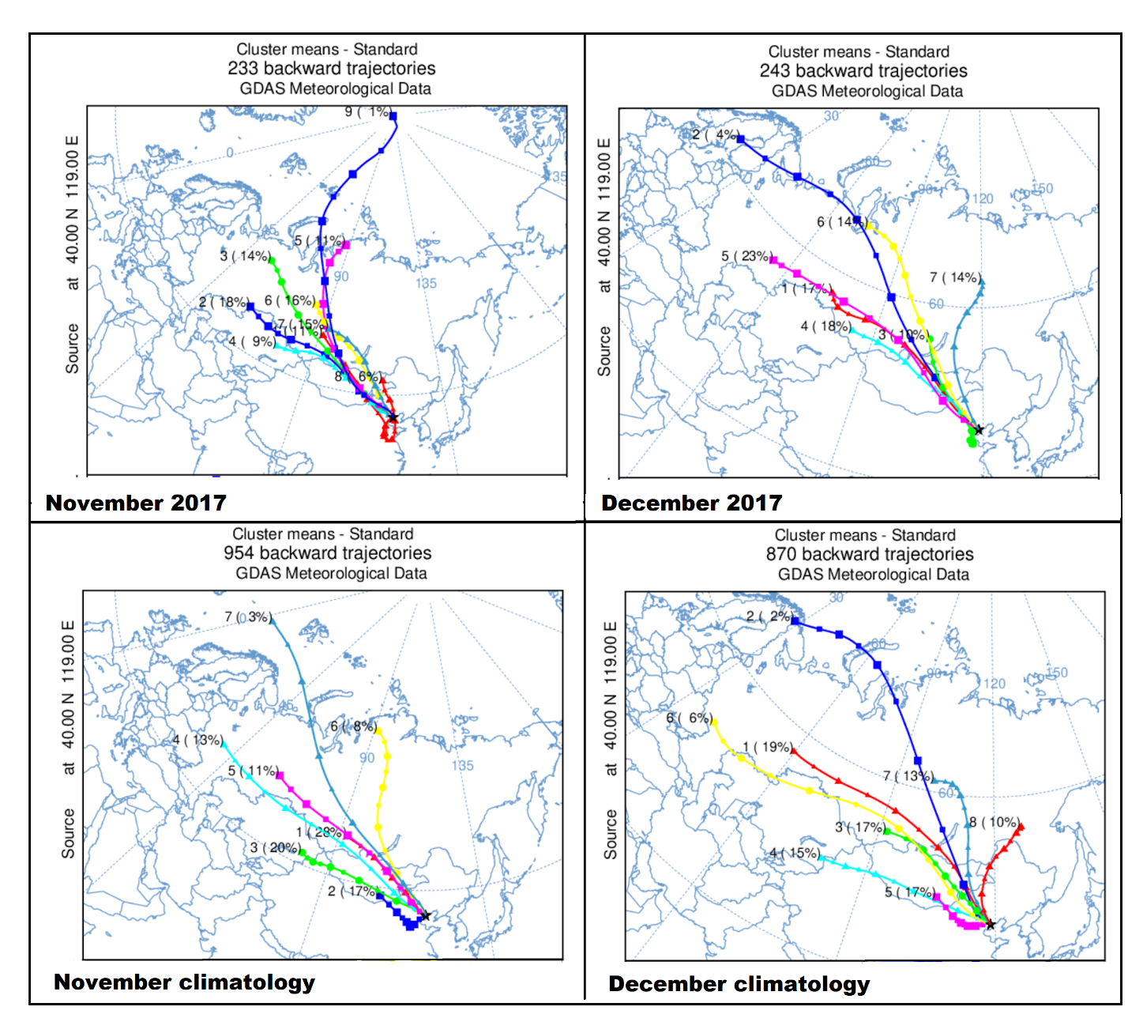

Figure 11: Panel representing MCs identified for the study periods in Beijing.

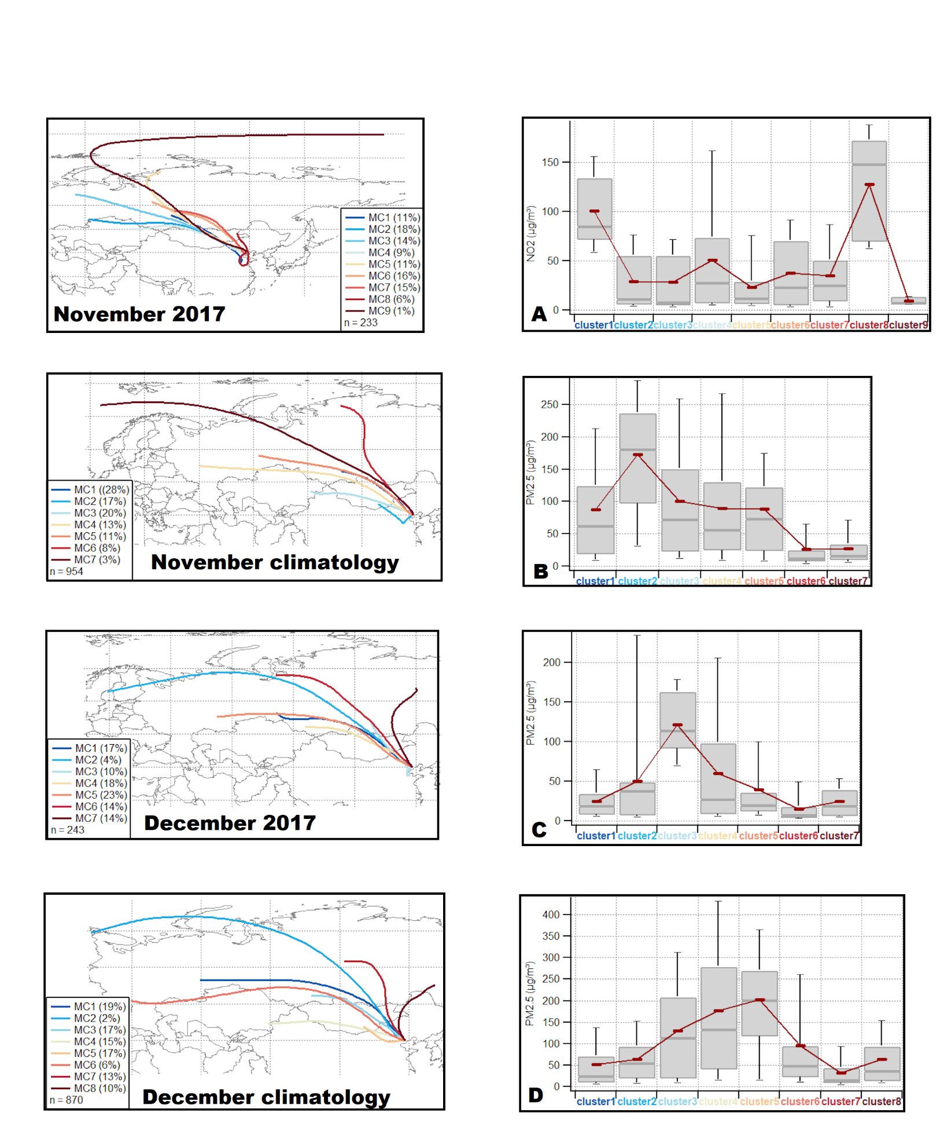

Figure 12: MC relative frequency and mean NO2 levels associated with each MC for Beijing in the study periods.

MC3 in climatology (20%) originated in Kazakhstan , travelling through Mongolia and inner Mongolia prior to arrival in Beijing. It had a similar travel path than MC4 in 2017 (9%), however, MC3 was associated with high mean PM2.5 concentrations, while MC4 was associated with nearly average concentrations. Considering the similar final section of their travel path over Beijing, but different concentrations, it is likely the different associated concentrations were due to a reduction in local emissions in Beijing during 2017.

MC1 in climatology and MC6 in 2017 also had similar characteristics to MC4 in 2017 (similar travel paths, similar residence time but MCs in 2017 were associated with) however, MC1 occurred more frequently in the climatology (28%) than MC4 in 2017 (9%) final stat

#### December less cluster travel in poll areas so rel contr is less, they are also carrying less conc

In climatology, most MCs (44%) were associated with nearly average PM2.5 mean concentrations (MC1, MC2, MC7 and MC8). 32% MCa were associated with extreme concentrations (MC4, MC5), and the minority was associated with high (23% MC3 and MC6). In December 2017, most clusters were associated with nearly average PM2.5 concentrations (90% from MC1, MC2, MC4, MC5, MC6 and MC7). MCs with high concentrations occurred rarely (10% MC2).

In climatology, MC5 and MC4 are associated with the highest mean PM2.5 concentrations (extreme). This might be justified by their travel paths over the industrial areas on the west and south west of Beijing (Shaanxi, Hebei and Shanxi). MC5 and MC4 are common in climatology (32% of total air masses, 15 for MC4 and 17% for MC5). In November, no MC had similar paths to MC4 and MC5 climatology. The MC associated with highest PM2.5 mean levels is MC3 (high). This cluster originated in southern Russia and recirculated over the polluted regions south of Beijing (Hebei and Shandong). However, MC3 in 2017 had lower mean PM2.5 concentrations than MC4 and MC5 in climatology, with lower frequency 2017. MC3 and MC6 in climatology were associated with high mean PM2.5 concentrations. These clusters had similar travel paths, however MC6 was faster than MC3. The lower residence time of MC6 in the polluted regions of western Beijing were reflected in the lower concentrations when compared to the longer residing MC3. MC3 and MC6 in climatology had a relative frequency of 23% (17% for MC3 and 6% for MC6). MC1 and MC5 in 2017 had analogous travel paths to MC3 and MC6 in climatology. However, these clusters were associated with a mean PM 2.5 concentration substantially lower than MC3 and MC6 in climatology. This is likely due to a reduction of emissions along the final stages of their travel paths. Furthermore, they occur with higher frequency in 2017 than in the climatology (40% total, 17% for MC1 and 23% for MC5). The remainder of the MCs were associated with a nearly average meanPM2.5 concentrations in both 2017 (MC2, MC4, MC6 and MC7) and the climatology (MC1, MC2, MC7, MC8). The relative frequency of these clusters was higher in 2017 (51%), than in climatology (44%).

Overall, it appears as clusters in 2017 were associated with lower mean PM2.5 concentrations than in the climatology. Furthermore, a higher frequency of air masses associated with lower concentrations was recorded in 2017 than in the climatology.

### CWT – Discuss why in Mongolia

The CWT reveals the sources of PM 2.5 in Beijing’s . As it can be seen in fig, (CWT) in both periods, the highest contributing sources are located In the immediate surroundings of Beijing, especially in the W, SW and S. These correspond to the heavily industrialised areas of southern Hebei, Henan E, Shanxi N, Shandong, Jiangsu N and N Anhui, Shaanxi, Eastern and Central Mongolia and Southern Russia. No particular differences are revealed by the CWT in terms of sources, all appears to have equal contribution towards the PM2.5 in Beijing when accounting that the climatology has 4 years of data compared to 2017, therefore the spead is larger because trajectories may have different contribution across different years. From the trajectory density it is clear that The concentration probabilities for potential sources are almost double for the climatologies than for 2017. A difference between the trajectory density in the two periods reveals local sources surrounding Beijing are significantly lower in 2017 than in the climatology. In November, the major contributing sources surrounding Beijing contribute up to 70 less ug/m3 than in the climatology. In December the difference is stricking, with contribution up to 110 ug/m3 less than in the climatology. The areas Western of Beijing have less pronounced differences, with N China contributing 20-30 ug.m3 less in November than the clim and slightly more (60-80 ug les in December).

# Conclusion